Aria Systems

FWK_Product_Request Builder
Request Builder Features List:
- Immediate Request:
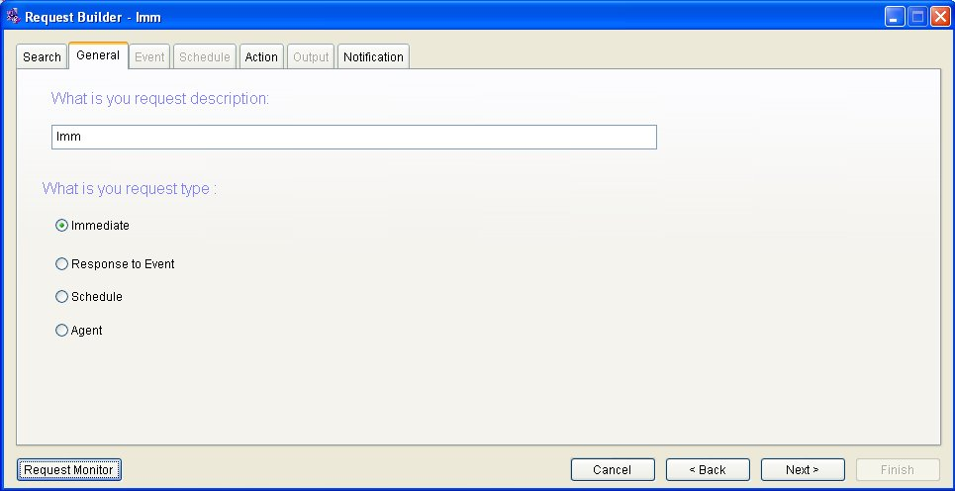
  - Generate report and don’t send email
    - Ability to generate report where output format is PDF
    - Ability to generate report where output format is Excel.
    - Ability to generate report where output format is Text.
    - Ability to generate report where output format is XML.
    - Ability to generate report where output format is HTML.

  - Generate report and send email and attach this report
    - Ability to generate report where output format is PDF
    - Ability to generate report where output format is Excel.
    - Ability to generate report where output format is Text.
    - Ability to generate report where output format is XML.
    - Ability to generate report where output format is HTML.
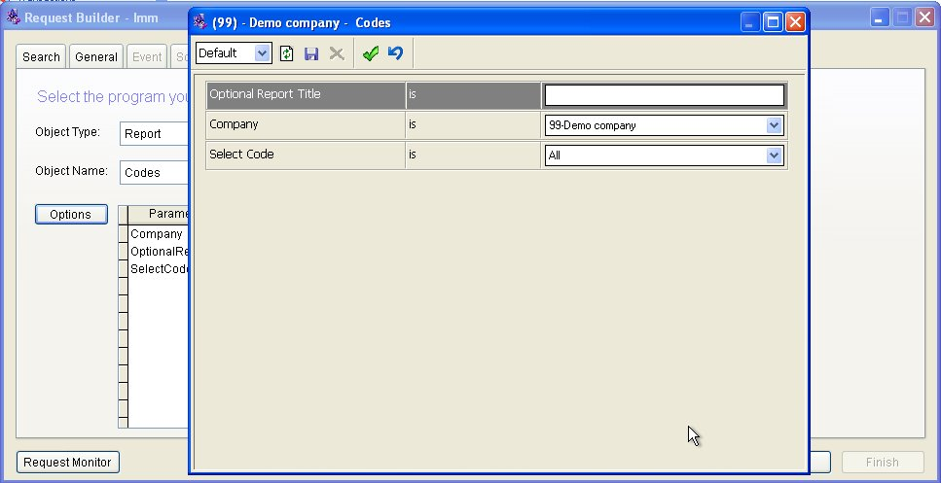
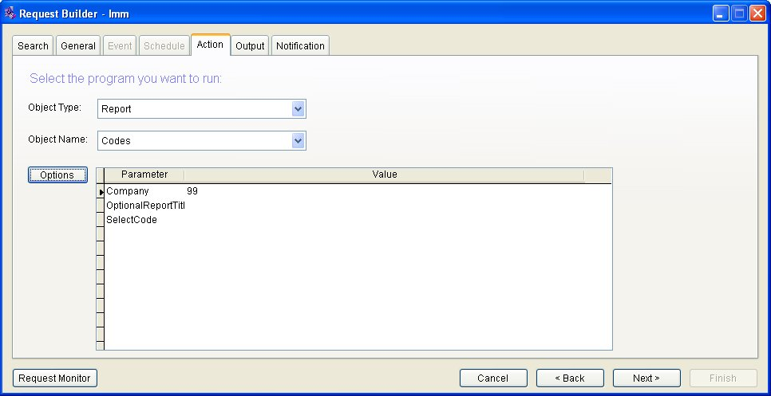
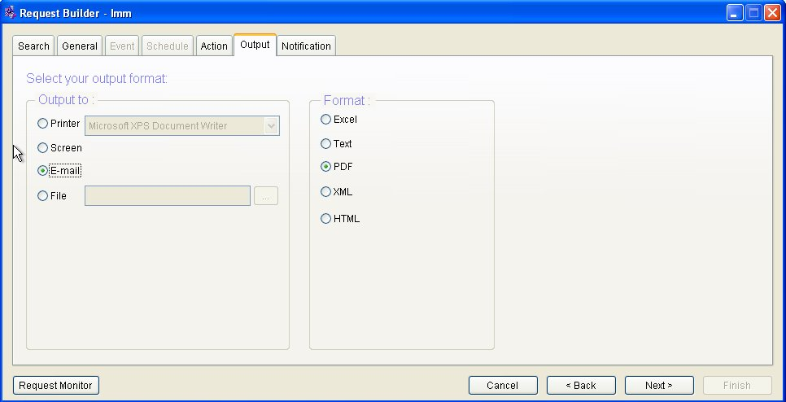
  - Ability to Substitution any drag Aria object fields.
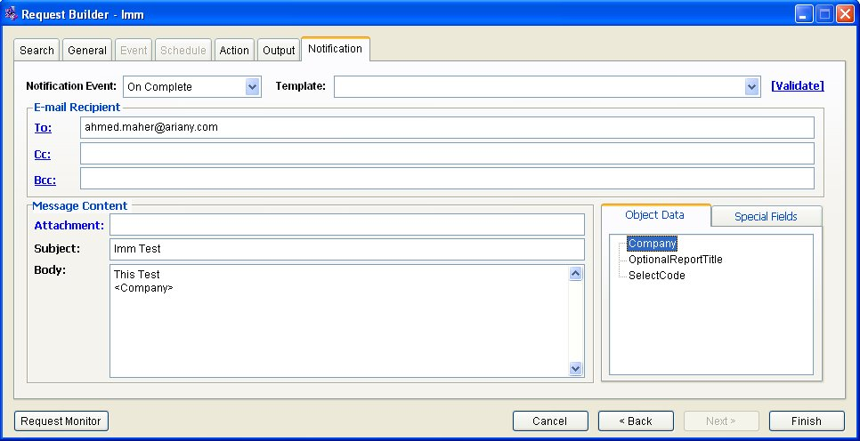

- Response to Event Request:
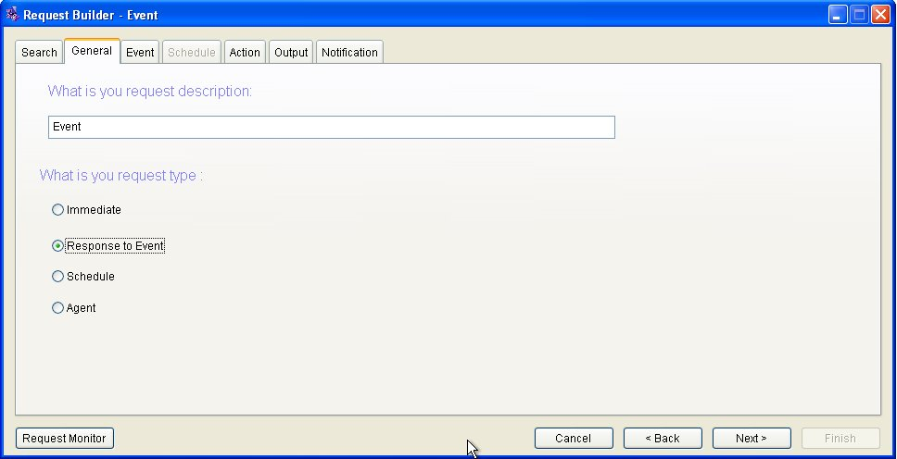
  - Can select object and assign type of event.
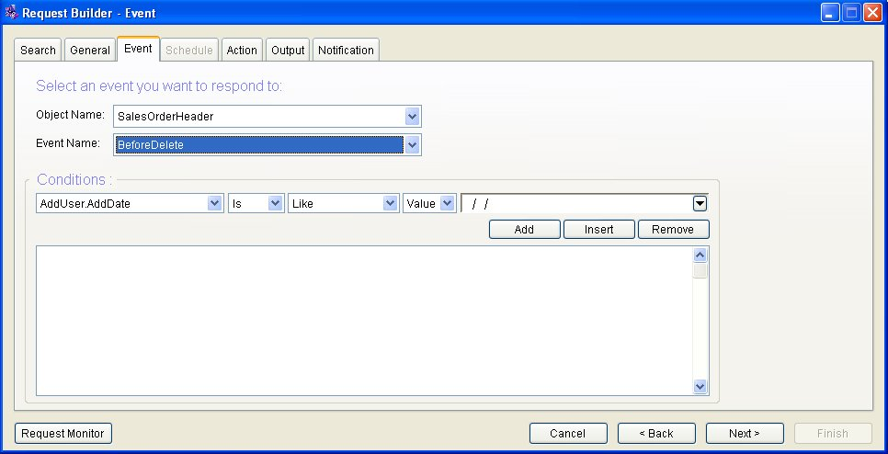
  - Can set some conditions.
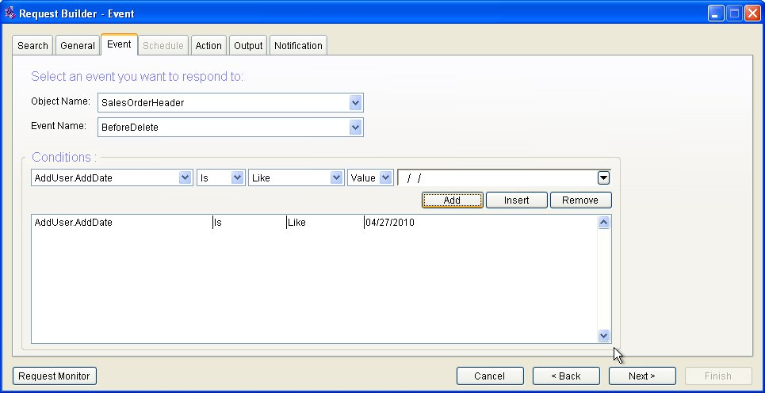
  - Ability to attach report of multi format.
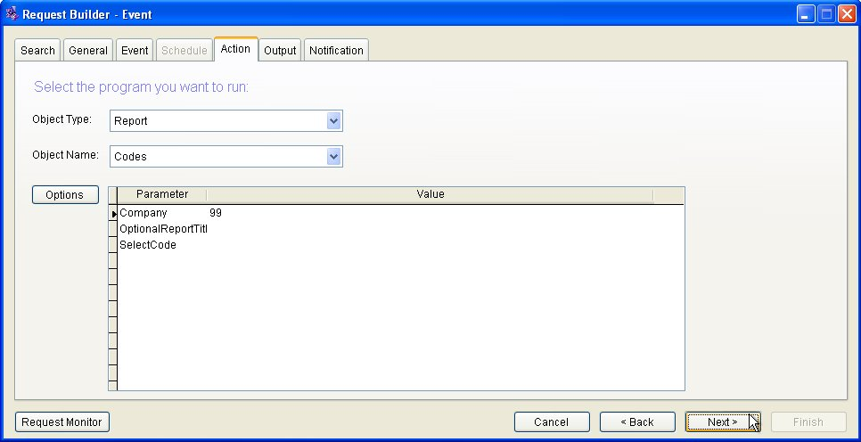
  - Can send email
  - Ability to Substitution any drag Aria object fields
  - Ability to add new object to list of object Events
1.6.1- this point can handle by adds new lines into Aria Object Event and Aria Object Event Parameter table in SYSTEM.MASTER DB and update SYDOBJCT in SQL Dictionary
1.6.1- screen that fire this event must be add DODEFULT () in event of saving.
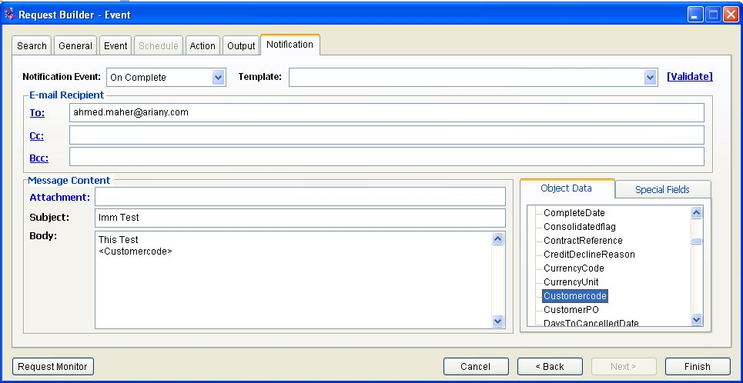
  - DAYSTO fields now work fine. ( Need to define what are “DaysTo” then example)
- Is calculated date where subtract filed of type date <in setting of AriaObjectProperty table> from system date where the result is number of days.

- Schedule Request
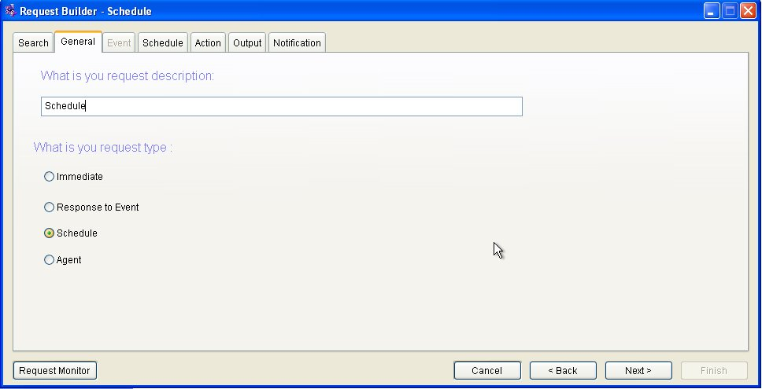
  - Ability to create new request as schedule and work fine and not hang.
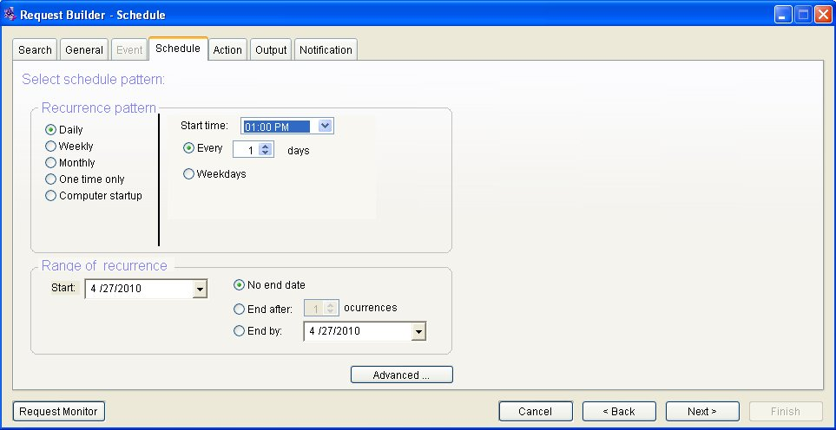
  - Ability to attach any report with any format.
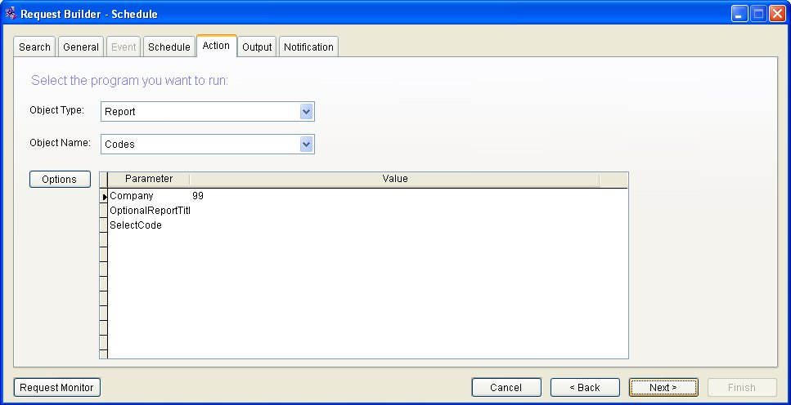
  - Ability to Substitution any drag Aria object fields
  - Can send email.
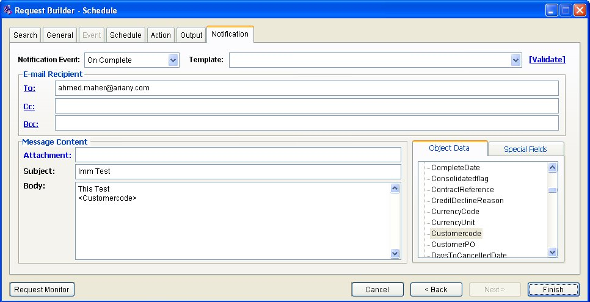
- Agent Request
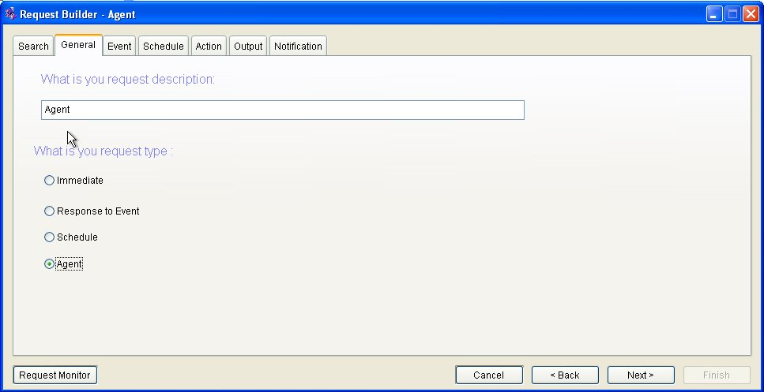
  - Ability to select any object and add to some conditions
    - DAYSTO conditions work fine ( Need to define what are “DaysTo” then example)
    - Fix conditions related of type Aria40Data or SQL table
    - Ability to Substitution any drag Aria object fields.
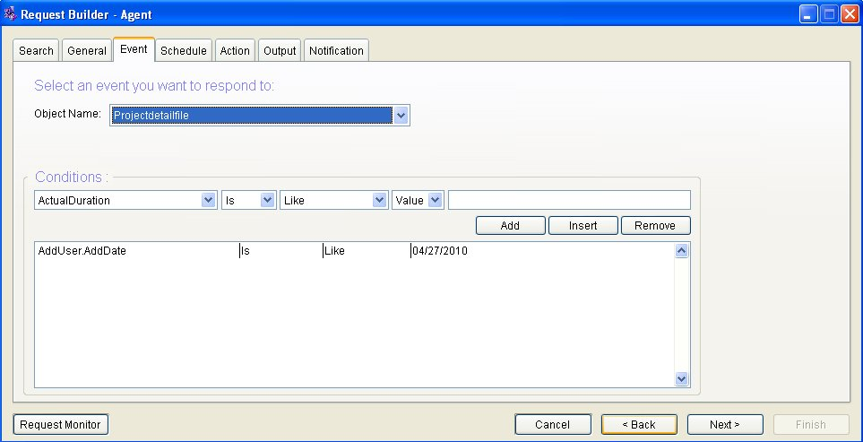
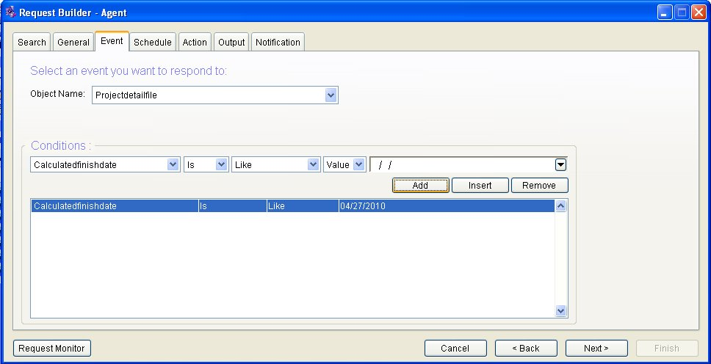
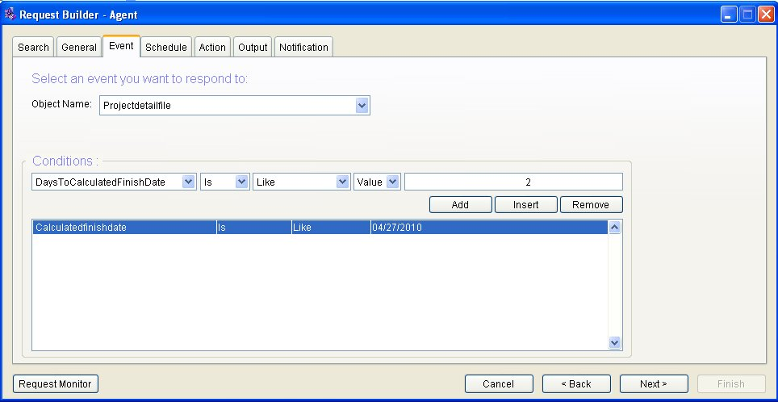
  - Can send email to <Notify> File in Project detail file, where email saved direct in this file in database
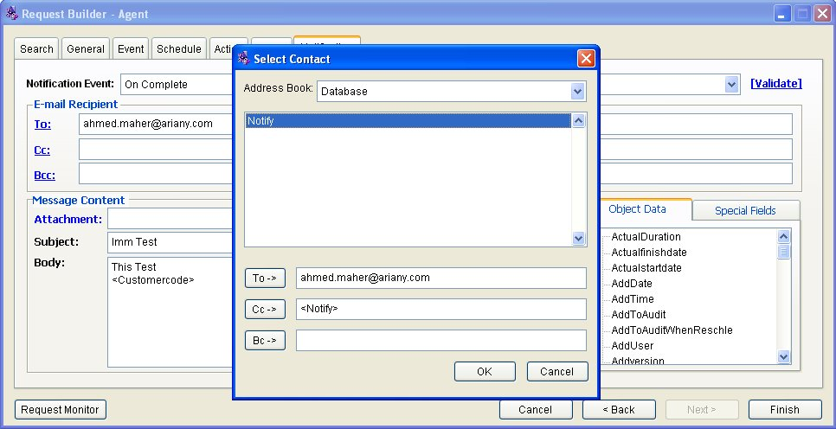
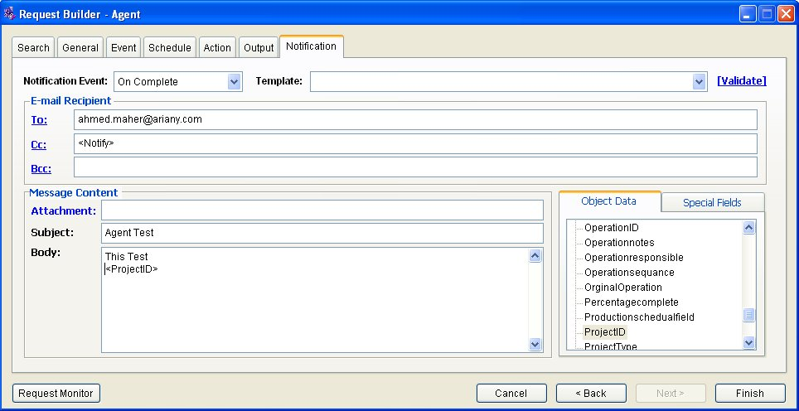
  - Can send email to any field of type ISEMAIL saved in SYSTEM.MASTER DB.
  - Ability to Substitution any drag Aria object fields.
1.4.1- Fix conditions related of type Aria40Data or SQL table.
  - Can send email.
  - Can select template email from created template.
  - Ability to create new request as schedule and work fine and not hang.

Special Feature of Request Builder:
- Problem and difficulty of registration is fixed
- Not must register any report (DLL,EXE) in COM+
- Can support work with multi instance of DB's on multi servers.
3.1- Update Aria Configuration server to apply Linked Server Fix.
Installed Request Builder
Server 1
System.Master& Aria.Master DB's
Server 2
Company's DB
Server 3
Company's DB
Server 3
Company's DB
Server 3
Server 4
Installed Aria4xp and Aria27

- Can Support multi Email provider that not support SSL and Microsoft exchange.
- Can enable un trusted user from access System.Master and Aria.Master (Error in connection when user not permission on windows)
- Can support any custom connection by some property add in Aria.Environment (to avoid any unknown case).
- Create Table call log and solution enable us from how any error generated and time of this error.
- Update some classes to use the last DLL.
- Fix System.Master <Dictionary>.
- Any adding of any object of type data in System.Master must be contain at lest on field as primary key.

